Question 1 (15 Marks) Marks

(a) Given that α = 3 + 2i and μ = 2 – 5i, find

(i) αμ 2
(ii) Re(αμ) 1
(iii) Im(αμ) 1

(b) Describe geometrically, on an Argand diagram

- Re(z) = 2. 1
- Im(z) < 2 1

(c) Expand and simplify 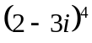 3

(d) Calculate the modulus of the product of the roots of the equation 3
(2 + i)x² + 3x – (1 – i) = 0.

(e) Show that the point representing cos+ isin is on a circle with radius 1 3
and centre at (1, 0).

Question 2 (15 Marks)

(a) The complex number z = 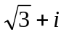is represented on an Argand diagram by the point A.

- The points B, C, D and E are the points representing −z, iz, 1 – z and 4
respectively. Mark clearly on an Argand diagram the points A, B, C, D, and E.
Clearly indicate important geometrical relationships between these points.

- F is the point in the second quadrant such that ∆ABF is equilateral. 2
What complex number is represented by the point F?

(b) (i) Find 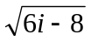, in the form a + ib. 3

(ii) Hence, solve the equation 2z² – (3 + i)z + 2 = 0, expressing the values of z 2
in the form a + ib.

(c) A point z on the Argand diagram is given by z = w² + 2iw, where w = u + iv
and u and v are real. Find the locus of z when

- u = 0 and v varies. 1
- v = 1 and u varies. 1
- Sketch the two loci, showing any important features. 2

Question 3 (15 Marks) Marks

(a) Sketch the locus |z + 2 – 3i| ≤ 5. 2

(b) Show that w = 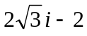 is a root of the equation z³ = 64. 2

(c) If z ≠ 0, show that u = z + 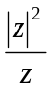 is always real, where z = x + iy and x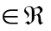 , y . 3

(d) If z = cosθ + isinθ, prove that 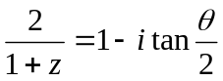. 3

(e) Sketch the region, in an Argand diagram where points satisfy the set of inequalities: 2
2 ≤ |z| ≤ 4 and 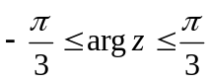.

(f) Prove that if Z₁, Z₂ are complex numbers then |Z₁ – Z₂| ² + |Z₁ + Z₂| ² = 2{|Z₁| ² +|Z₂| ²}. 3

Question 4 (15 Marks)

(a) 2 – i is one root of x² – (3 – i)x + k = 0. Find k and the other root of the equation. 2

(b) Sketch the region in the Argand diagram defined by 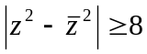 3

(c) (i) Show that (1 + i) is a root of the polynomial P(x) = x³ + x² – 4x + 6. 2
(ii) Hence resolve P(x) into irreducible factors over the complex field. 3

(d) Find the fourth roots of 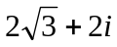. 5

 END OF EXAM ☺

